Making A Key Ring

Student now create a mini sized key ring to attach to their school bag. The key ring should contain
- Your name
- The digital photo
- House
- Your home address if you wish

- Make a personalised key ring – Use a digital camera to photograph yourself (use other students) create in Paintshop Pro a miniature picture with your name to fit inside the key ring provided.

- On the reverse put your phone number and a nice picture – to fit the reverse of the key ring.

Making The Key Ring SIDE 1

- Take a photograph of yourself using the digital camera
- Using Paint Shop Pro save the image to your folder
- Open Microsoft Word
- From Insert Click on Picture from file
- Insert your Photograph
- Click on the picture ONCE ONLY (This selects it)
- From Format – Click on Picture
- Click on the Size tab
- Deselect lock Aspect Ratio – click in the largest size width or height
- Make the size 3.3mm
- Insert a Text Box and Type Your Name (This Must fit 3.3cm wide)
- Place this over the Photograph Format the textbox if you want a transparent background Click on Colour and make it NO FILL

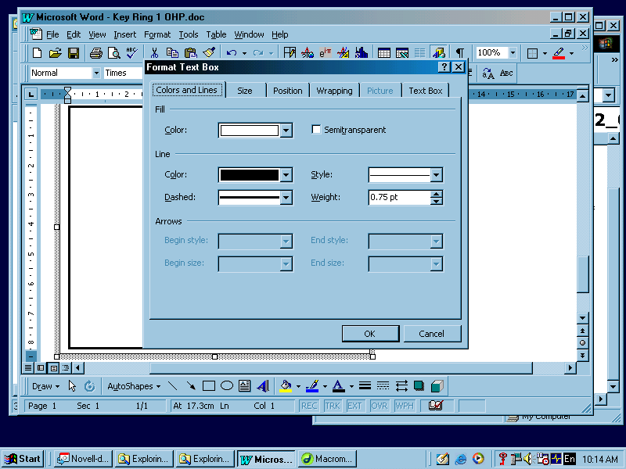
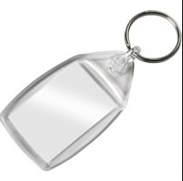

MAKING A KEYRING Reverse SIDE 2

- Open Microsoft Word
- From Insert Click on Picture from File -


FINDING THE GRAPHICS FILE

- From The Shared Students Folder Mars Vol1
- Open the folder Technology
- Open Folder 2004
- Open Graphics Folder
- Open Great Scenes folder or any folder with nice pictures in it
- Click on the picture ONCE ONLY (This selects it)
- From Format – Picture

- Click on the Size tab
- Deselect lock Aspect Ratio – click in the largest size width or height
- Make the size 3.3mm

Using Text Box type your Phone Number or Mobile number and place this box over the picture (DO NOT PUT YOUR ADDRESS ON KEYRINGS THAT MAY HOLD YOUR HOUSE KEYS)

Format the box if you want a transparent background Click on Colour and make it NO FILL


Need help just ask

